Report of | Meeting | Date
Director of Finance | Governance Committee | Tuesday, 29 November 2022
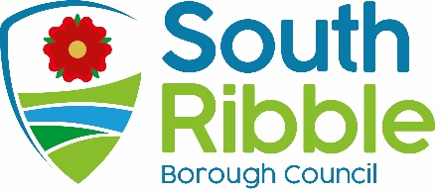

Statement of Accounts 2021/22

Is this report confidential? | No

Is this decision key? | No

Savings or expenditure amounting to greater than £100,000 | N/A

Purpose of the Report
- To present for approval the audited Statement of Accounts for 2021/22.

Recommendations
- To approve the audited Statement of Accounts for 2021/22 (Appendix A), subject to any amendments which, in the opinion of the Director of Finance (Section 151 Officer), are minor in nature, i.e. defined as non-material to the financial position of the council;

- To delegate authority to the Director of Finance, in consultation with the Chair of Governance Committee, to make such amendments;

- If the Director of Finance is of the opinion that any such amendments are material to the financial position of the council, to reconvene the Governance Committee to approve the new Statement of Accounts;

- To authorise the Director of Finance and Chair of Governance Committee to sign the Letter of Representation (Appendix B).

Reasons for recommendations
- Approval of the annual Statement of Accounts is a statutory obligation.

Other options considered and rejected
- The Statement of Accounts are prepared in the form to meet professional accounting standards and to comply with statutory regulations. There are therefore no alternative options that can be adopted.

Corporate priorities

- The report relates to the following corporate priorities:

An exemplary council | Thriving communities
A fair local economy that works for everyone | Good homes, green spaces, healthy places

Background to the report

- The Accounts and Audit Regulations came into force on the 1st April 2015 and have subsequently been amended, most recently by the Accounts and Audit (Amendment) Regulations 2022, which became effective from 22nd July 2022. These regulations set the statutory timetable for production, approval and audit of the Statement of Accounts.

- The responsible financial officer must sign and date the Draft Statement of Accounts and certify that it presents a true and fair view of the financial position of the Authority at the year end, and of the income and expenditure for the year.

- The responsible financial officer must then commence the period for the ‘exercise of public rights’ and notify the local auditor of the date on which that period commenced; for the 2021/22 statements the timescale for doing so was 31st July 2022.

- There is no requirement for Members to approve the Statement of Accounts at this stage in the process.

- The responsible financial officer must, on behalf of the authority, publish (which must include publication on the authority’s website) the draft Statement of Accounts, along with the Annual Governance Statement and a Narrative Report and a declaration, signed by that officer, to the effect that the status of the statement of accounts is unaudited and that the approved Statement of Accounts, as published, may be subject to change.

- The regulations also state that the period for the exercise of public rights is deemed to commence on the day following the day on which all of these obligations have been fulfilled. The responsible finance officer must also ensure that commencement of the period for the exercise of public rights takes place on such a day that it includes, for the 2021/22 statements, the first ten working days of August 2022 and continues for a single period of 30 working days.

- Once the full draft Statement of Accounts have been published, and the public inspection period has begun, then the audit of the accounts by the council’s external auditors, Grant Thornton, can commence.

- Once the audit has been completed, the Regulations specify that the responsible financial officer must reconfirm on behalf of the authority that they are satisfied that the statement of accounts present a true and fair view of the financial position of the authority at the year end, and the income and expenditure for the year. The council is then required to:

  - consider, either by way of a committee, or by the members meeting as a whole, the statement of accounts;
  - approve the statement of accounts by a resolution of that committee or meeting;
  - ensure that the statement of accounts is signed and dated by the person presiding at the committee or meeting at which that approval is given.

- South Ribble Borough Council delegates the responsibility for the approval of the accounts to the Governance Committee.

- For 2021/22, the date for completion of the audit and final approval and publication of the Statement has been determined in the Regulations as 30 November 2022.

- Once approved the council must, by no later than 30 November, publish:
- the statement of accounts together with any certificate or opinion, entered by the local auditor;
- the annual governance statement; and
- the narrative statement.

- Publication of the final documents must include publication on the council’s website. Approval of the Statement of Accounts 2021/22

- The draft Statement of Accounts 2021/22 were signed by the Director of Finance on 4 August 2022 and published on the Council’s website, together with details of public inspection rights. Whilst every effort was made, this was slightly beyond the deadline set by government due to resources available within the Finance Team. Grant Thornton, the external auditors, were kept fully informed of the position, and on 4 August the accounts were presented to them for audit.

- The Auditor’s ‘Audit Findings Report’ is presented as a separate report on this agenda. This sets out adjusted misstatements, unadjusted misstatements, and misclassification and disclosure changes in the current version of the Statement of Accounts. The audit of the accounts has not yet been completed in full. A few matters are still under consideration and so there is a possibility that further changes to the Statement of Accounts may be required. The details of the work yet to be undertaken is stated on page 3 of their report.

- The Accounts and Audit Regulations 2015, as amended by The Accounts and Audit (Amendment) Regulations 2022, require that the statement should be approved by a meeting of members by 30 November 2022, or should that not prove possible, ‘as soon as is reasonably practicable after the receipt of any report from the auditor which contains the auditor’s final findings from the audit which is issued before the conclusion of the audit’.

- The full statement for 2021/22 is attached as Appendix A for consideration and approval.

- Following consideration and approval by this Committee, the Chair is required to sign and date the Statement, which should also be re-certified by the Director of Finance, as soon as is practicable. The Statement of Accounts will then be published on the South Ribble Council web site; www.southribble.gov.uk.

- The Director of Finance and the Chair of Governance Committee should also sign the Letter of Representation which is attached at Appendix B.

- As the audit has not yet been fully completed, it is recommended that the Director of Finance, in consultation with the Chair of Governance Committee, should approve any further non-material amendments to the Statement of Accounts, if necessary, before the accounts are signed and dated. If the Director of Finance is of the opinion that the amendments are material to the financial position of the council, Governance Committee should be reconvened to approve the new Statement of Accounts.

Changes to Draft Statement of Accounts Published on 4 August 2022.

- Appendix C of the Audit Findings Report sets out the main adjustments made to the Statement of Accounts from the version published on 4 August 2022.

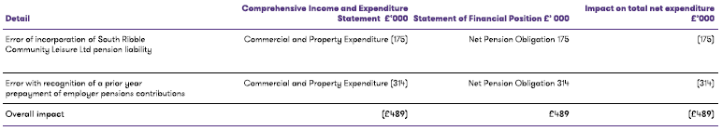

- In addition, further misclassification and disclosure changes have been made to the accounts as outlined in page 28 of their report.

- One adjustment that has been identified by the auditors that has not been actioned in the accounts as it is not material to the accounts is detailed on page 29 of their report

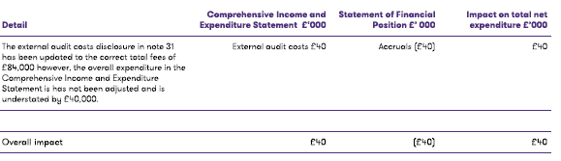

- The Annual Governance Statement is unchanged from that approved by the Committee on 24 May 2022.

Climate change and air quality

- The report does not impact the climate change and sustainability targets of the Councils Green Agenda and all environmental considerations are in place.

Equality and diversity
- This report has no implications in respect of equality and diversity.

Risk

- Risk implications apply in relation to compliance with the Accounts and Audit Regulations 2015 (as amended) 2022, and in preparing financial statements in accordance with the statutory timetable. The accounts must be compliant with the relevant standards and must be prepared on a true and fair view basis. Failure to comply could result in a failure to meet the statutory duty

Comments of the Statutory Finance Officer

- There are no direct financial implications arising from this report. The report meets the statutory accounting requirements for the Statement of Accounts to be produced and is a factual statement of the income and expenditure flows over the course of the 2021/22 financial year, and a snapshot of the Balance Sheet position as at 31st March 2022.

- All financial implications relating to the final budget outturn position have been set out in the Revenue and Capital Outturn Reports 2021/22, which were considered by Cabinet on 20 June 2022.

Comments of the Monitoring Officer

- The legal implications are in respect of the Accounts and Audit Regulations 2015 (as amended) 2022, and the requirement that the accounts must be compliant with the relevant accounting standards and codes of practice and must be prepared on a true and fair view basis. Failure to comply could result in a failure to meet the statutory duty.

Background documents
- Accounts and Audit (England) Regulations 2015 (as amended) 2022
- CIPFA Code of Practice on Local Authority Accounting in the United Kingdom 2021/22

Appendices

- Appendix A: Draft (Audited) Financial Statements 2021/22
- Appendix B: Draft Letter of Representation 2021/22

Report Author: | Email: | Telephone: | Date:
Louise Mattinson (Director of Finance) | louise.mattinson@southribble.gov.uk | 01772 625625 | 29 Nov 2022

